**Recording JMeter Script**

Download JMeter from [Apache JMeter - Download Apache JMeter](https://jmeter.apache.org/download_jmeter.cgi)

Extract the file and go to the folder and run JMeter.bat to open the JMeter application

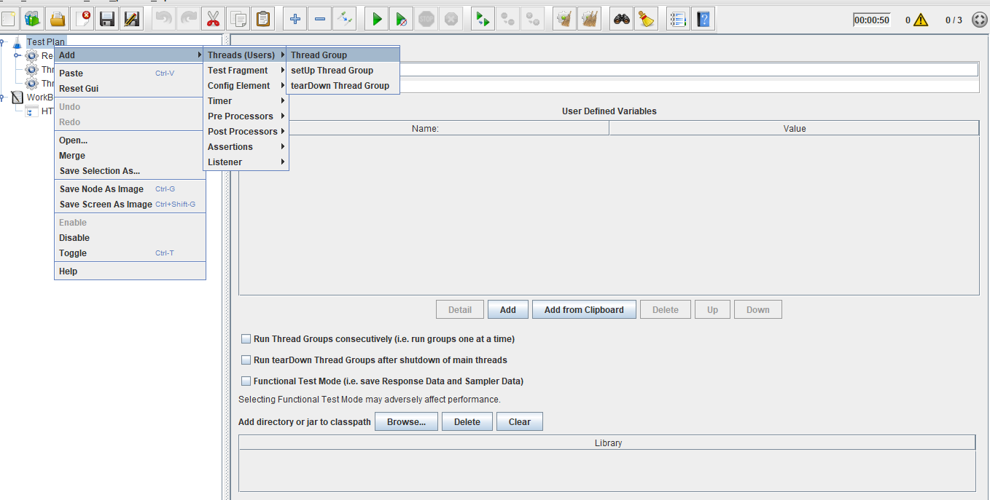

Click on Add -> NonTest Elements -> Http(s) Test Script Recorder.

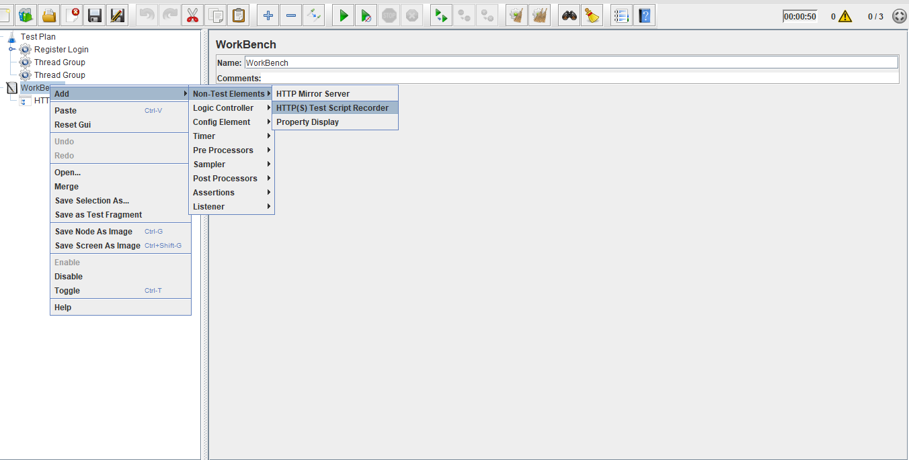

Right click on Thread Group.

Click on Add -> Logic Controller -> Recording Controller.

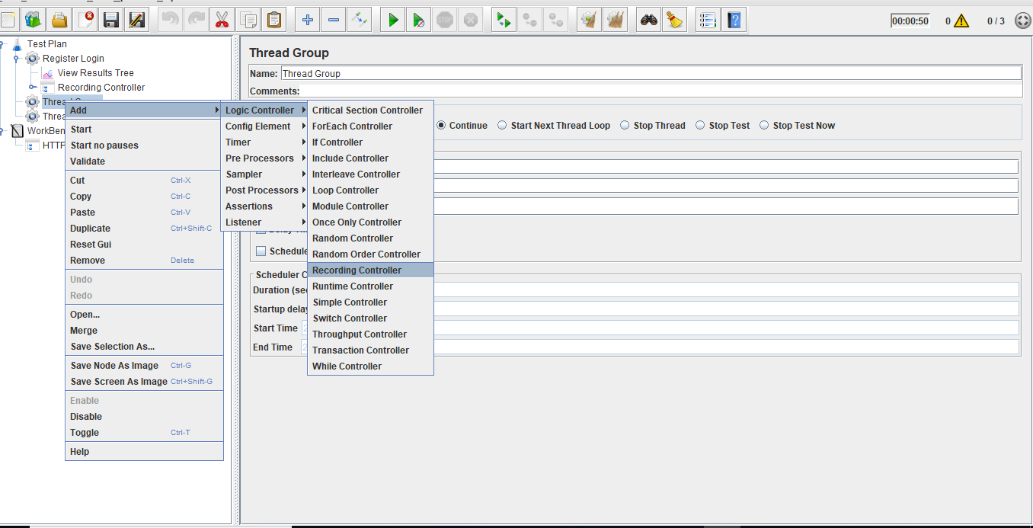

Right click on Thread Group.

Click on Add -> Listener -> View Result in Tree.

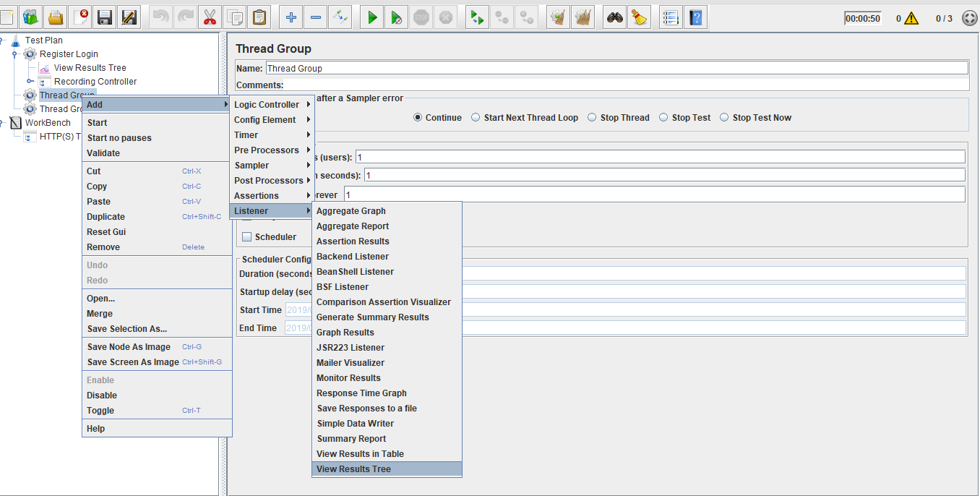

Go to system settings and go to proxy to change it to localhost and port number as 8181

Open the website you want to check in a browser, example: Firefox.

Recording Controller records the script.

View the results in **View Result Tree**.

You can add it.

